Post | Image
To ensure accountability and transparency of health reform we advocate for structures to be created including an Aboriginal and Torres Strait Islander Health Equity Board to oversee health equity strategy accountability measures.  For more information visit the link in our bio.  Tag  - Queensland Labor Party - @qldlabor  - Liberal National Party of Queensland - @lnpqld  - Katter’s Australian Party - @the_kap_official  - Queensland Greens - @queenslandlandgreens  - Pauline Hanson’s One Nation Queensland Division - @onenationaus  - North Queensland First – @nq_first  - Shooters, Fishers and Farmers Party - @shootersfishersfarmers  - Animal Justice Party (Queensland) - @animaljusticeparty  - Civil Liberties & Motorists Party [No Instagram]  - Clive Palmer’s United Australia Party - @clivepalmer_unitedaustralia  #qldelection2020 #healthequity #Queensland #health #QAIHC #Aboriginal #TorresStraitIslander | 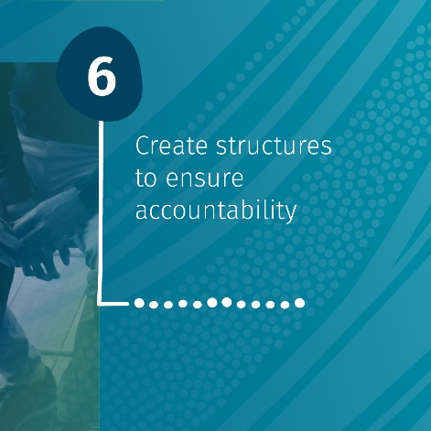
Visit the link in our bio to access our 2020 Queensland State Election Member Service Guide and political asks for this State Election.

#qldelection2020 #healthequity #Queensland #health #QAIHC #Aboriginal #TorresStraitIslander
This Queensland State Election we advocate for the creation of a health system that delivers high value, family centred care for Aboriginal and Torres Strait Islander Queenslanders that is free from racism.  We need health reforms that puts our people at the centre of decision making for their own health, that recognises the role and capability of ATSICCHOs and that shifts care out of hospitals and into community. For more information visit the link in our bio.  Tag  - Queensland Labor Party - @qldlabor  - Liberal National Party of Queensland - @lnpqld  - Katter’s Australian Party - @the_kap_official  - Queensland Greens - @queenslandlandgreens  - Pauline Hanson’s One Nation Queensland Division - @onenationaus  - North Queensland First – @nq_first  - Shooters, Fishers and Farmers Party - @shootersfishersfarmers  - Animal Justice Party (Queensland) - @animaljusticeparty  - Civil Liberties & Motorists Party [No Instagram]  - Clive Palmer’s United Australia Party - @clivepalmer_unitedaustralia  #qldelection2020 #healthequity #Queensland #health #QAIHC #Aboriginal #TorresStraitIslander | 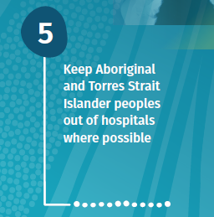
Visit the link in our bio to access our 2020 Queensland State Election Member Service Guide and political asks for this State Election.  #qldelection2020 #healthequity #Queensland #health #QAIHC #Aboriginal #TorresStraitIslander | 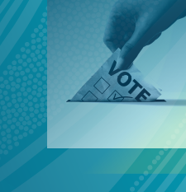
This Queensland State Election we ask political candidates to devolve non-acute care to the Aboriginal and Torres Strait Islander Community Controlled Health Sector and other culturally safe health care providers.  For more information visit the link in our bio.  Tag  - Queensland Labor Party - @qldlabor  - Liberal National Party of Queensland - @lnpqld  - Katter’s Australian Party - @the_kap_official  - Queensland Greens - @queenslandlandgreens  - Pauline Hanson’s One Nation Queensland Division - @onenationaus  - North Queensland First – @nq_first  - Shooters, Fishers and Farmers Party - @shootersfishersfarmers  - Animal Justice Party (Queensland) - @animaljusticeparty  - Civil Liberties & Motorists Party [No Instagram]  - Clive Palmer’s United Australia Party - @clivepalmer_unitedaustralia  #qldelection2020 #healthequity #Queensland #health #QAIHC #Aboriginal #TorresStraitIslander | 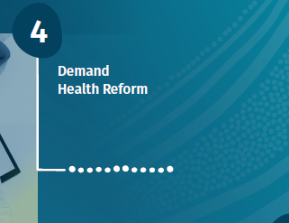
Visit the link in our bio to access our 2020 Queensland State Election Member Service Guide and political asks for this State Election.

#qldelection2020 #healthequity #Queensland #health #QAIHC #Aboriginal #TorresStraitIslander
This Queensland State election we ask political candidates to eradicate interpersonal and institutional racism through actively fostering a culture of diversity in their community.  For more information visit the link in our bio.  Tag  - Queensland Labor Party - @qldlabor  - Liberal National Party of Queensland - @lnpqld  - Katter’s Australian Party - @the_kap_official  - Queensland Greens - @queenslandlandgreens  - Pauline Hanson’s One Nation Queensland Division - @onenationaus  - North Queensland First – @nq_first  - Shooters, Fishers and Farmers Party - @shootersfishersfarmers  - Animal Justice Party (Queensland) - @animaljusticeparty  - Civil Liberties & Motorists Party [No Instagram]  - Clive Palmer’s United Australia Party - @clivepalmer_unitedaustralia  #qldelection2020 #healthequity #Queensland #health #QAIHC #Aboriginal #TorresStraitIslander | 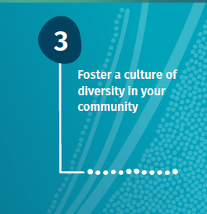
Visit the link in our bio to access our 2020 Queensland State Election Member Service Guide and political asks for this State Election.  #qldelection2020 #healthequity #Queensland #health #QAIHC #Aboriginal #TorresStraitIslander | 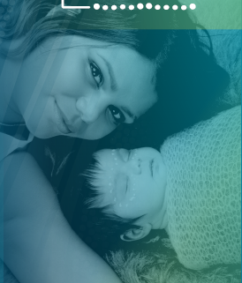
The New National Agreement on Closing the Gap gives us a louder voice than ever before. Aboriginal and Torres Strait Islander peoples are now a part of the decision making process so we can improve our lives now and in the future.  This state election we will talk about the importance of Closing the Gap and how we want to work with our future State government.  For more information visit the link in our bio.  Tag  - Queensland Labor Party - @qldlabor  - Liberal National Party of Queensland - @lnpqld  - Katter’s Australian Party - @the_kap_official  - Queensland Greens - @queenslandlandgreens  - Pauline Hanson’s One Nation Queensland Division - @onenationaus  - North Queensland First – @nq_first  - Shooters, Fishers and Farmers Party - @shootersfishersfarmers  - Animal Justice Party (Queensland) - @animaljusticeparty  - Civil Liberties & Motorists Party [No Instagram]  - Clive Palmer’s United Australia Party - @clivepalmer_unitedaustralia  #qldelection2020 #healthequity #Queensland #health #QAIHC #Aboriginal #TorresStraitIslander | 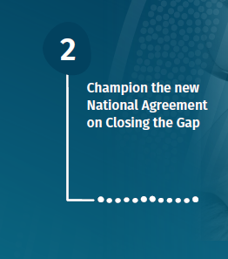
Visit the link in our bio to access our 2020 Queensland State Election Member Service Guide and political asks for this State Election.

#qldelection2020 #healthequity #Queensland #health #QAIHC #Aboriginal #TorresStraitIslander
This Queensland State Election we advocate for Equity for Aboriginal and Torres Strait Islander peoples. We ask all political candidates to support legislation that will ensure health equity and address institutional racism in the health system by holding hospitals accountable to Health Equity Strategies.  For more information visit the link in our bio.  Tag  - Queensland Labor Party - @qldlabor  - Liberal National Party of Queensland - @lnpqld  - Katter’s Australian Party - @the_kap_official  - Queensland Greens - @queenslandlandgreens  - Pauline Hanson’s One Nation Queensland Division - @onenationaus  - North Queensland First – @nq_first  - Shooters, Fishers and Farmers Party - @shootersfishersfarmers  - Animal Justice Party (Queensland) - @animaljusticeparty  - Civil Liberties & Motorists Party [No Instagram]  - Clive Palmer’s United Australia Party - @clivepalmer_unitedaustralia  - Metro North Hospital and Health Service – [No Instagram]  - Sunshine Coast Hospital and Health Service – [No Instagram]  - Townsville Hospital and Health Service – [No Instagram]  - Cairns and Hinterland Hospital and Health Service - @ cairnshinterlandhhs  - Central Queensland Health – [No Instagram]  - Central West Hospital and Health Service – [No Instagram]  - Darling Downs Health - @darlingdownshealth  - Children’s Health Queensland – [No Instagram]  - Gold Coast Health - @goldcoast.health  - Mackay Hospital and Health Service – [No Instagram]  - Metro South Health - @metrosouthhealth  - North West Hospital and Health Service – [No Instagram]  - South West Hospital and Health Service – [No Instagram]  - Torres and Cape Hospital and Health Service – [No Instagram]  - West Moreton Health - @westmoretonhealth  - Wide Bay Hospital and Health Service – [No Instagram]  #qldelection2020 #healthequity #Queensland #health #QAIHC #Aboriginal #TorresStraitIslander | 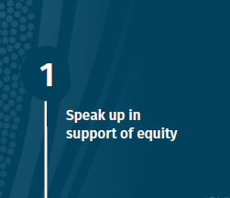
Visit the link in our bio to access our 2020 Queensland State Election Member Service Guide and political asks for this State Election.  #qldelection2020 #healthequity #Queensland #health #QAIHC #Aboriginal #TorresStraitIslander | 