Post | Image
To ensure accountability and transparency of health reform we advocate for structures to be created including an Aboriginal and Torres Strait Islander Health Equity Board to oversee health equity strategy accountability measures.  An Aboriginal and Torres Strait Islander Health Equity Board would ensure:  - the relevance and impact of the strategies  - community-driven decision making  - high-level co-design of the regulation’s framework  - strategies are not HHS strategies but community strategies  - state-wide consistency, transparency and accountability for the implemented strategies.  Share this post with your friends and family and tag your local politicians.  Tag  - Queensland Labor Party - @qldlabor  - Liberal National Party of Queensland - @LNPQLD  - Katter’s Australian Party - @KattersAusParty  - Queensland Greens - @QueenslandGreens  - Pauline Hanson’s One Nation Queensland Division - @OneNationParty  - North Queensland First – @NQFirst  - Shooters, Fishers and Farmers Party - @SFFparty  - Animal Justice Party (Queensland) - @AJPQLD  - Civil Liberties & Motorists Party - @MotoristsParty  - Clive Palmer’s United Australia Party - @CliveFrederickPalmer  - Radio ‘4 Meriba Wakai’ - @4MW  - Bumma Bippera Media 987fm - @BBM987FM  - NIRS - @NIRSNews  - ABC Brisbane - @abcinbrisbane  #qldelection2020 #healthequity #Queensland #health #QAIHC #Aboriginal #TorresStraitIslander | 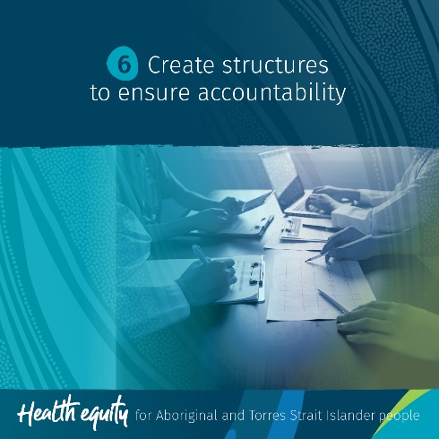
This Queensland State Election we ask political candidates to devolve non-acute care to the Aboriginal and Torres Strait Islander Community Controlled Health Sector and other culturally safe health care providers.  Keeping Aboriginal and Torres Strait Islander peoples out of hospitals where possible, means that:  - where there are hospital services that can be operated in community, they should be devolved to community, such as non-acute care like renal services, allied health services, specialist appointments etc.  - we want to stop people from getting so ill that they need to go to hospital (through investment in preventative health).  Share this post with your friends and family and tag your local politicians.  For more information visit www.qaihc.com.au/resources/2020-queensland-state-election  Tag  - Indigenous Allied Health Australia - @IndigenousAlliedHealthAustralia  - First Peoples Disability Network - @FPDNaus  - Queensland Labor Party - @qldlabor  - Liberal National Party of Queensland - @LNPQLD  - Katter’s Australian Party - @KattersAusParty  - Queensland Greens - @QueenslandGreens  - Pauline Hanson’s One Nation Queensland Division - @OneNationParty  - North Queensland First – @NQFirst  - Shooters, Fishers and Farmers Party - @SFFparty  - Animal Justice Party (Queensland) - @AJPQLD  - Civil Liberties & Motorists Party - @MotoristsParty  - Clive Palmer’s United Australia Party - @CliveFrederickPalmer  - Radio ‘4 Meriba Wakai’ - @4MW  - Bumma Bippera Media 987fm - @BBM987FM  - NIRS - @NIRSNews  - ABC Brisbane - @abcinbrisbane  #qldelection2020 #healthequity #Queensland #health #QAIHC #Aboriginal #TorresStraitIslander #communitycontrol #preventativehealth | 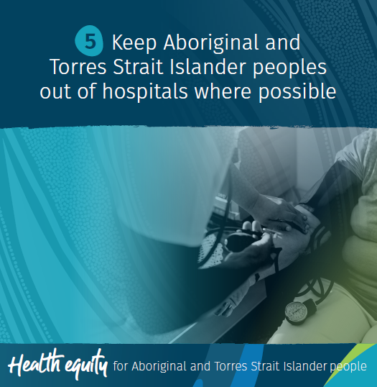
This Queensland State Election we advocate for the creation of a health system that delivers high value, family centred care for Aboriginal and Torres Strait Islander Queenslanders that is free from racism.  What is health reform?  In June 2020, the Deputy Premier Hon. @stevenmilesmp, commissioned a Reform Planning Group to report on health reform options in Queensland Health in light of COVID-19 and the need for better ways of working.  What would health reform mean to Aboriginal and Torres Strait Islander peoples?  A streamlined health system from ATSICCHO through to hospital where you only need to tell your story once, you can access the treatment you need as close to home as possible (or with transport provided) and you feel safe at all times.  Share this post with your friends and family and tag your local politicians.  For more information visit www.qaihc.com.au/resources/2020-queensland-state-election  Tag  - Queensland Labor Party - @qldlabor  - Liberal National Party of Queensland - @LNPQLD  - Katter’s Australian Party - @KattersAusParty  - Queensland Greens - @QueenslandGreens  - Pauline Hanson’s One Nation Queensland Division - @OneNationParty  - North Queensland First – @NQFirst  - Shooters, Fishers and Farmers Party - @SFFparty  - Animal Justice Party (Queensland) - @AJPQLD  - Civil Liberties & Motorists Party - @MotoristsParty  - Clive Palmer’s United Australia Party - @CliveFrederickPalmer  - Radio ‘4 Meriba Wakai’ - @4MW  - Bumma Bippera Media 987fm - @BBM987FM  - NIRS - @NIRSNews  - ABC Brisbane - @abcinbrisbane  #qldelection2020 #healthequity #Queensland #health #QAIHC #Aboriginal #TorresStraitIslander #QueenslandHealth #ATSICHSBrisbane #ATSICHSMackay #ApunpimaCapeYork #CRAICCHS #Bidgerdii #CarbalMedicalServices #CWAATSICH #CunnamullaAboriginalCorporation #GalangoorDuwalami #Girudala #Goolburri #Goondir #GurrinyYealamucka #Injilinji #Kalwun #Kambu #Mamu #GidgeeHealing #MudthNiyleta #Mulungu #Nhulundu #NCACCH #NPAFamilyandCommunity #TAIHS #Wuchopperen #YuluBurriBa #IUIH #NATSIHA | 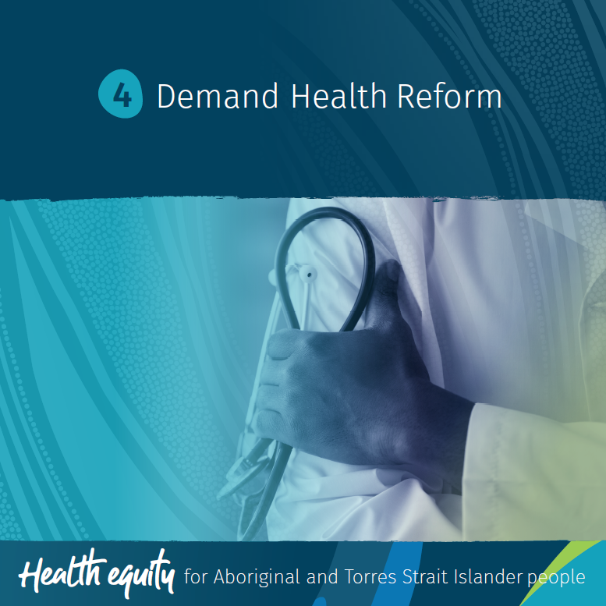
This Queensland State election we call on political candidates to eradicate interpersonal and institutional racism.  Interpersonal racism is discrimination perpetrated by one individual against another individual because of their race. It can be seen through relationships, behaviours and words.  Institutional racism is discrimination perpetrated through systems, structures and organisations which discrimination against a group based on their race.  QAIHC and its Members experience the impact of institutional racism every day and are witness to the direct impact that systemic bias has on health outcomes for Aboriginal and Torres Strait Islander peoples.  Education and understanding is key to changing perceptions.  Share this post with your friends and family and tag your local politicians.  For more information visit www.qaihc.com.au/resources/2020-queensland-state-election  Tag  - Queensland Labor Party - @qldlabor  - Liberal National Party of Queensland - @LNPQLD  - Katter’s Australian Party - @KattersAusParty  - Queensland Greens - @QueenslandGreens  - Pauline Hanson’s One Nation Queensland Division - @OneNationParty  - North Queensland First – @NQFirst  - Shooters, Fishers and Farmers Party - @SFFparty  - Animal Justice Party (Queensland) - @AJPQLD  - Civil Liberties & Motorists Party - @MotoristsParty  - Clive Palmer’s United Australia Party - @CliveFrederickPalmer  - Queensland Human Rights Commission -@QueenslandHumanRightsCommission  - Radio ‘4 Meriba Wakai’ - @4MW  - Bumma Bippera Media 987fm - @BBM987FM  - NIRS - @NIRSNews  - ABC Brisbane - @abcinbrisbane  #qldelection2020 #healthequity #Queensland #health #QAIHC #Aboriginal #TorresStraitIslander #RacismItStopsWithMe #FightRacism | 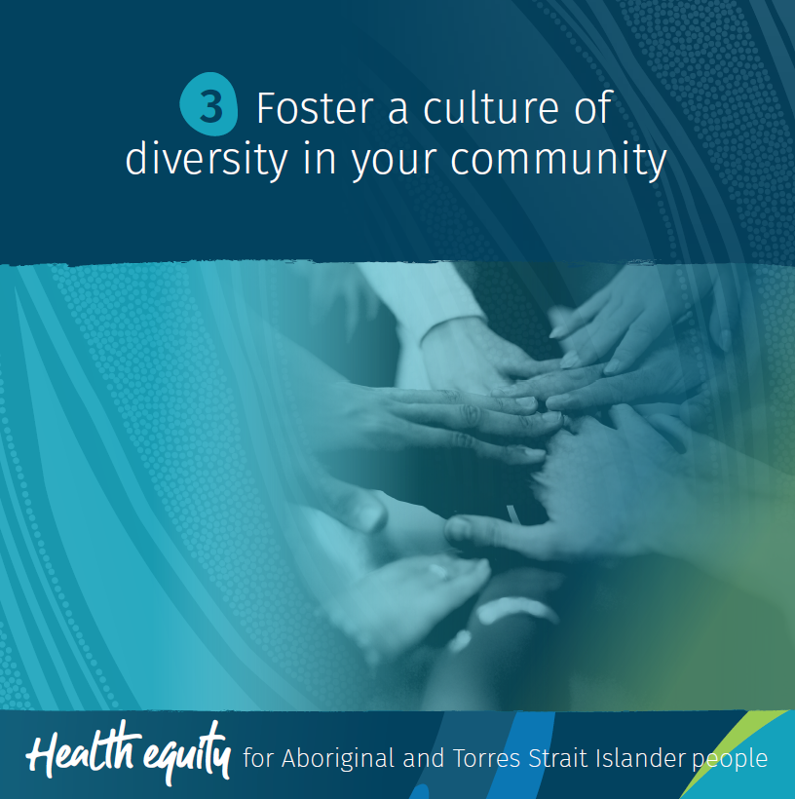
The National Agreement on Closing the Gap was launched by the Coalition of Peaks (CoP) on 30 July 2020. The COP is made up of over 50 Aboriginal and Torres Strait Islander community-controlled peak and member organisations across Australia.  The National Agreement is a commitment from all governments to fundamentally change the way they work with Aboriginal and Torres Strait Islander communities and organisations through four Priority Reforms:  - Shared decision-making  - Building the community-controlled sectors  - Improving mainstream institutions  - Aboriginal and Torres Strait Islander-led data.  We ask political candidates, in partnership with Queensland’s Aboriginal and Torres Strait Islander communities and the community-controlled sectors, to implement the National Agreement on Closing the Gap.  Share this post with your friends and family and tag your local politicians.  For more information visit www.qaihc.com.au/resources/2020-queensland-state-election  Tag  - Queensland Labor Party - @qldlabor  - Liberal National Party of Queensland - @LNPQLD  - Katter’s Australian Party - @KattersAusParty  - Queensland Greens - @QueenslandGreens  - Pauline Hanson’s One Nation Queensland Division -@OneNationParty  - North Queensland First – @NQFirst  - Shooters, Fishers and Farmers Party - @SFFparty  - Animal Justice Party (Queensland) - @AJPQLD  - Civil Liberties & Motorists Party - @MotoristsParty  - Clive Palmer’s United Australia Party - @CliveFrederickPalmer  - Radio ‘4 Meriba Wakai’ - @4MW  - Bumma Bippera Media 987fm - @BBM987FM  - NIRS - @NIRSNews  - ABC Brisbane - @abcinbrisbane  #qldelection2020 #healthequity #Queensland #health #QAIHC #Aboriginal #TorresStraitIslander | 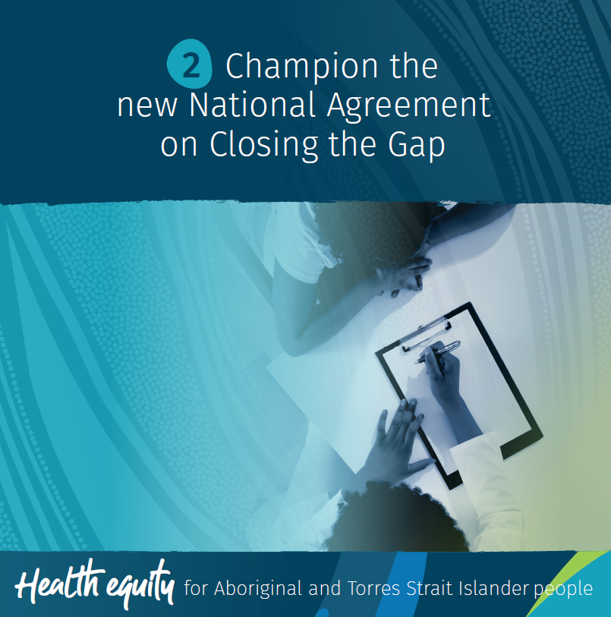
What is the difference between equality and equity?  Equality is about everyone being treated equally. Sometimes this doesn’t lead to the best outcomes as everyone is not always starting from the same place.  Equity is about everyone being treated fairly.  This Queensland State Election we advocate for Equity for Aboriginal and Torres Strait Islander peoples; we are asking our politicians to support legislation that will ensure health equity and to honestly address institutional racism in the health system by holding hospitals accountable to Health Equity Strategies.  Share this post with your friends and family and tag your local politicians.  For more information visit www.qaihc.com.au/resources/2020-queensland-state-election  Tag  - Queensland Labor Party - @qldlabor  - Liberal National Party of Queensland - @LNPQLD  - Katter’s Australian Party - @KattersAusParty  - Queensland Greens - @QueenslandGreens  - Pauline Hanson’s One Nation Queensland Division - @OneNationParty  - North Queensland First – @NQFirst  - Shooters, Fishers and Farmers Party - @SFFparty  - Animal Justice Party (Queensland) - @AJPQLD  - Civil Liberties & Motorists Party - @MotoristsParty  - Clive Palmer’s United Australia Party - @CliveFrederickPalmer  - Metro North Hospital and Health Service - @MetroNorthHHS  - Sunshine Coast Hospital and Health Service - @SunshineCoastHHS  - Townsville Hospital and Health Service - @townsvillehhs  - Cairns and Hinterland Hospital and Health Service - @cairnsandhinterland  - Central Queensland Health - @cqhealth  - Central West Hospital and Health Service - @CentralWestHHS  - Darling Downs Health - @darlingdownshealth  - Children’s Health Queensland - @childrenshealthqld  - Gold Coast Health - @GCHealth  - Mackay Hospital and Health Service - @mackayhhs  - Metro South Health - @metrosouthhealth  - North West Hospital and Health Service - @NorthWestHHS  - South West Hospital and Health Service - @southwesthhs  - Torres and Cape Hospital and Health Service - @torrescapehhs  - West Moreton Health - @wmhhs  - Wide Bay Hospital and Health Service - @widebayhealth  - Radio ‘4 Meriba Wakai’ - @4MW  - Bumma Bippera Media 987fm - @BBM987FM  - NIRS - @NIRSNews  - ABC Brisbane - @abcinbrisbane  #qldelection2020 #healthequity #Queensland #health #QAIHC #Aboriginal #TorresStraitIslander | 